|  |  |  |
| --- | --- | --- |
| 5 | **.**  **.**  **.**  **.**  **.**  **.**  **.**  **.**  **.**  **.**  **.**  **.**  **.**  **.**  **.**  **.**  **.**  **.**  **.**  **.**  **.**  **.**  **.**  **.**  **.**  **.**  **.**  **.**  **.**  **.**  **.** | **Database Processing** |

|  |  |
| --- | --- |
| CHAPTER LEARNING OBJECTIVE QUESTIONS |  |

5-1 Why Do You Need to Know About Databases?

5-2 What Is a Database?

5-3 What Is a Database Management System (DBMS)?

5-4 How Do Database Applications Make Databases More Useful?

5-5 How Can eHermes Benefit from a Database System?

5-6 What Are Nontraditional DBMS Products?

Learning Catalytics™ is a student response tool that helps you generate class discussion, customize your lecture, and promote peer-to-peer learning based on real-time analytics. Learning Catalytics uses students’ smartphones, tablets, or laptops to engage them in more interactive tasks.

|  |  |
| --- | --- |
| SO WHAT? |  |

## Slick Analytics

1. *Have you chosen to store any of your personal data in the cloud? If so, do you store all of your data or only certain types of data? If not, what factors have inhibited you from putting your data in the hands of a cloud provider? If you don’t use cloud-based storage, how do you back up your data?*

Student responses will vary. It’s likely that most students are familiar with using Google Drive to share files with professors and student team members. Discussions of other types of data students choose to store in the cloud and the need for backups will make for an interesting conversation.

1. *This article discussed the specific example of a petroleum company using cloud-based data analytics to improve decision making. What other industries can you identify that would benefit from the ability to capture large quantities of data in real time, analyze the data, and then use the results of those analyses to make better decisions?*

Perhaps a better question is: are there any industries that would not benefit from the ability to capture large quantities of data in real time, analyze the data, and then use the results of those analyses to make better decisions? The only industries that come to mind that could be prohibited from using cloud-based analytics are those that are legally required to know specifically where their data is located, such as banks and other financial institutions.

1. *This article mentions that some users may decide to manage their data “in house” rather than use cloud-based services and risk losing access to their data in the event of a DoS attack. Take a few minutes to research what a DoS attack is and how it could prevent users from accessing their data. Be prepared to explain this concept to another classmate or to the class.*

A DoS attack is a type of attack launched by hackers targeting an organization’s web servers. The hackers arrange for massive volumes of service requests to be directed to the web servers. The huge volume of requests overwhelms the web servers and they are no longer able to respond to any requests, effectively shutting down the web site. If a cloud-service provider’s site was brought down by a DoS attack, the legitimate users who have data stored there would be unable to access that data until the attack was contained and the web servers restored to full operating strength.

1. *In a business setting, what types of organizations would place greater value on security than convenience? What types of organizations would prioritize convenience over security?*

Companies that store large quantities of highly sensitive data, such as financial or health care organizations, should place greater value on security than convenience. Organizations that are mostly using cloud storage to make publicly available data more easily accessible would prioritize convenience over security. An example might be a company that is providing product lists and details to its sales force.

|  |  |
| --- | --- |
| COLLABORATION EXERCISE 5 |  |

*Using the collaboration IS you built in Chapter 1 (pages 25–26), collaborate with a group of students to answer the following questions. If you haven’t built your collaboration IS yet, reread Collaboration Exercise 1 and Chapter Extension 10. Meet with your team and build a collaboration IS that uses tools like Google Docs, SharePoint, or other collaboration tools. Do not forget the need for procedures and team training.*

1. *Study Figure 5-16 to understand the entities and their relationships. Justify each of the cardinalities in this model. For the definition of cardinality, see CE6.*

* Customer / Item: a Customer may purchase many Items; an Item is Purchased by one Customer.
* An Item instance is optional for a Customer instance; a Customer instance is required for an Item instance.
* A MobileStore may contain many Items; an Item is contained in one MobileStore.
* An Item instance is optional for a MobileStore instance; a MobileStore instance is required for an Item instance.
* An Item may contain many ClassifiedProducts; a ClassifiedProduct belongs to one Item.
* A ClassifiedProduct instance is optional for an Item; an Item instance is required for a ClassifiedProduct instance.

(LO: 1, Learning Outcome: Discuss best practices for using and managing databases, AACSB: Analytic Skills)

1. *Working with your team, develop a list of seven queries that together use all of the entities in Figure 5-16.*

Student answers will vary; here is a sample list of queries.

1. List the items offered for sale by each customer for a particular month.
2. List all the items in a particular mobile store.
3. List all the items in a particular mobile store at or below a list price.
4. List all the items offered by customer X at a specific mobile store.
5. List all the classified product items for a specific mobile store.
6. List all the items in a particular mobile store for a specific seller type.
7. List the items at a mobile store grouped by condition.

(LO: 6, Learning Outcome: Discuss best practices for using and managing databases, AACSB: Analytic Skills)

1. *Modify the E-R model in Figure 5-16 to include a Contact entity that is related to the Facility entity. Create the relationship, and specify and justify the relationship’s cardinalities.*

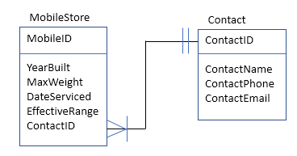

In the above model, we assume that each MobileStorehas one Contact person, and each Contact person represents at least one and possibly more MobileStores. We are assuming that eHermes’ organization may have several MobileStores but may use the same contact person for more than one MobileStore; this seems a reasonable assumption. (LO: 5, Learning Outcome: Discuss best practices for using and managing databases, AACSB: Analytic Skills)

1. *Discuss the advantages and disadvantages of the model you created in your answer to question 5-6 and the model in Figure 5-16.*

If we wanted to store the information about the designated contact person for a MobileStore, then we could add the contact-related attributes to the MobileStore entity, or we could create a separate Contact entity, as shown above. The advantage of this model would be the elimination of transitive dependencies in the MobileStore entity (ContactPhone depends only on ContactName, not on MobileID). It will be much easier to keep the data up to date in the new model since we can change the contact information for a MobileStore in one place rather than have to search through all MobileStore records to change the contact information. The disadvantage is a slightly slower search process because of the added entity. (LO: 6, Learning Outcome: Discuss best practices for using and managing databases, AACSB: Analytic Skills)

1. *Transform the data model in Figure 5-16 into a relational database design.* Hint*: Create a table for each entity and relate those tables.*

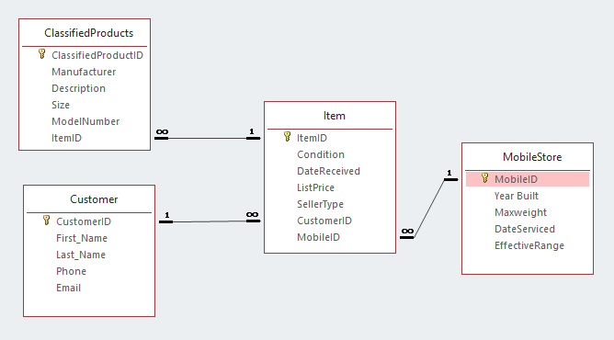

(LO: 6, Learning Outcome: Discuss best practices for using and managing databases, AACSB: Analytic Skills)

1. *Create an Access database for your design in question 5-8.*

No specific answer provided. An activity to be performed by the team. (LO: 6, Learning Outcome: Discuss best practices for using and managing databases, AACSB: Analytic Skills)

1. *Fill your database with sample data. Because you do not have files on a server, leave the URL column blank.*

No specific answer provided. An activity to be performed by the team. (LO: 6, Learning Outcome: Discuss best practices for using and managing databases, AACSB: Analytic Skills)

1. *Using the Access query facility, process each of the seven queries you created in your answer to question 5-5.*

Student answers will vary. A sample of results is shown below for the queries posed in question 5-5:

1. List the items offered for sale by each customer for a particular month (in this example, November 2018).

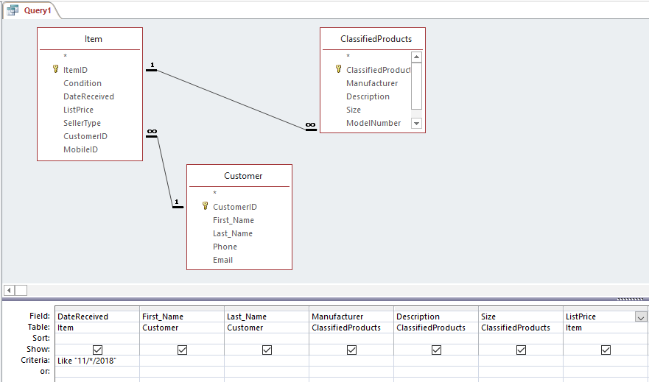

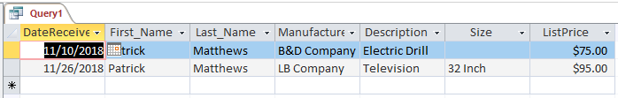

1. List all the items in a particular mobile store (in this example, Mobile Store #2).

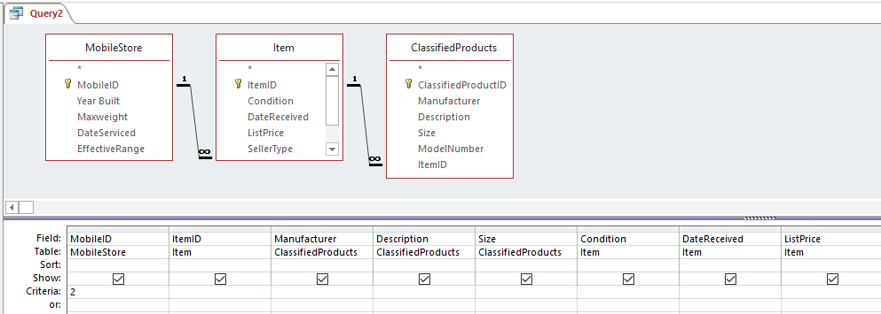

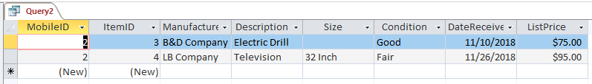

1. List all the items in a particular mobile store at or below a list price (in this example, Items in Mobile Store #1 below $100).

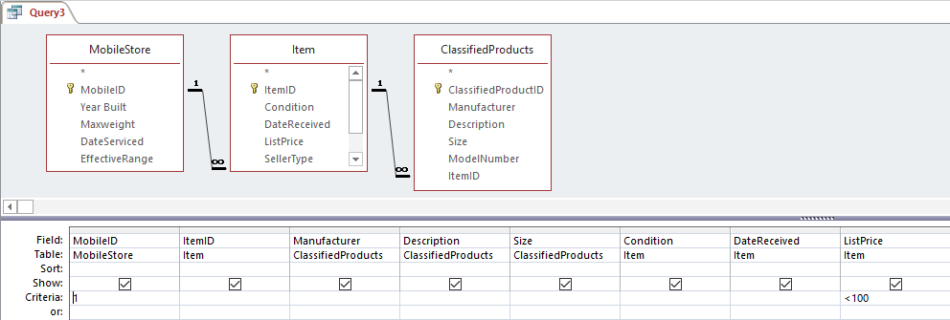

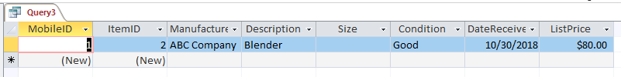

1. List all the items offered by customer X at a specific mobile store (in this example, Carol Williams at Mobile Store #1).

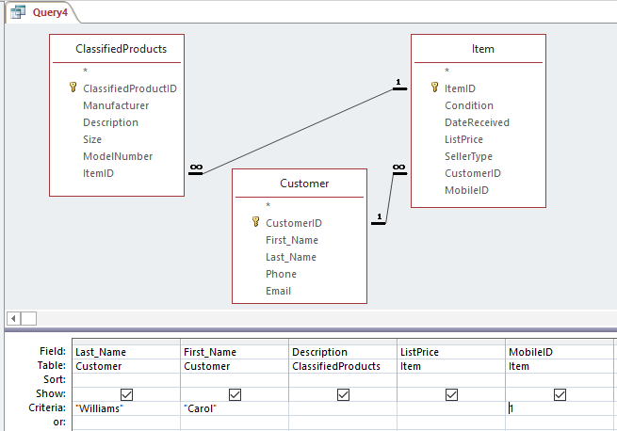

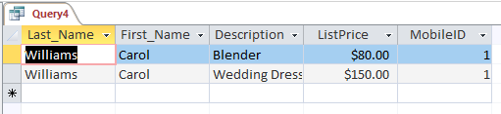

1. List all the classified product items for a specific mobile store (in this case, for Mobile Store #2).

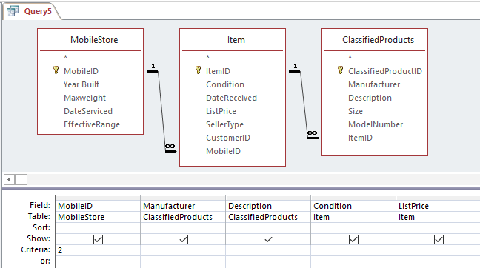

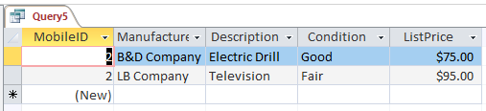

1. List all the items in a particular mobile store for a specific seller type (in this case, Regular customers at Mobile Store #1).

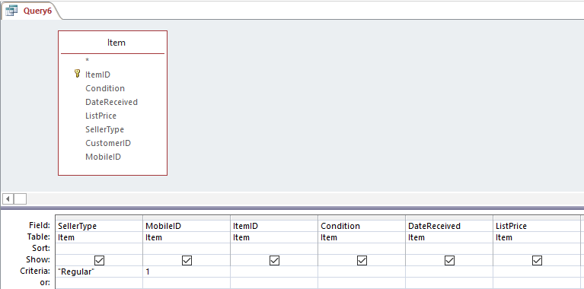

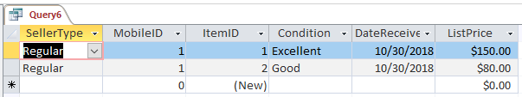

1. List the all the items listed by date received for all mobile stores.

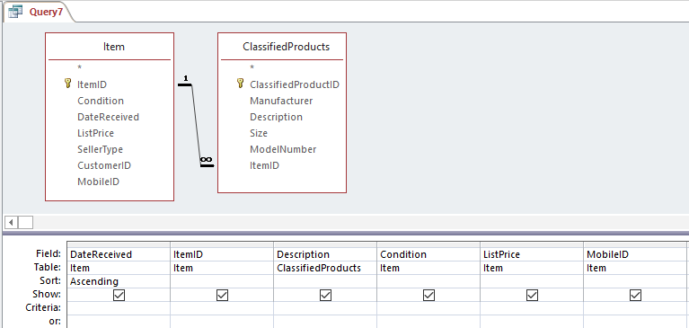

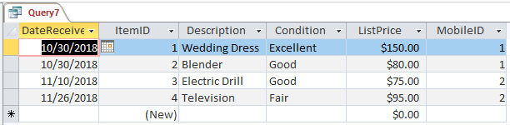

|  |  |
| --- | --- |
| CASE STUDY 5 |  |

## Searching for Pianos…

1. *Explain why a one-table database could be stored just as readily in Excel as in Access.*

Since Dean is tracking data on just one theme (pianos) he could use a spreadsheet and adequately manage his piano inventory. (LO: 1, Learning Outcome: Discuss best practices for using and managing databases, AACSB: Information Technology)

1. *Justify the decision to use Access to store the piano database.*

Planning ahead and recognizing some of the questions he will want to answer in the future leads to the conclusion that being able to query a database will very useful. If a spreadsheet was used, the answers could only be produced through sorting methods and would not be very satisfactory. (LO: 1, Learning Outcome: Discuss best practices for using and managing databases, AACSB: Information Technology)

1. *Examine the columns in Figure 5-20. Name three characteristics of pianos that are not represented in this table.*

Several items come to mind that are not included. Date acquired, price paid, repairs/renovations needed, repairs/renovations made; when the sound quality or other condition features were last assessed. (LO: 5, Learning Outcome: Discuss best practices for using and managing databases, AACSB: Analytical Thinking)

1. *If you were a consultant advising Dean, what criteria should you and he use in deciding whether to include that additional data?*

Any time changes are being considered to an information system, the costs and benefits must be weighed. Dean should consider whether having the additional facts about his inventory available will be worth the cost of adding these fields and filling them in for his existing inventory records. (LO: 5, Learning Outcome: Discuss best practices for using and managing databases, AACSB: Analytical Thinking)

1. *Is this database a model of an inventory of pianos, or is it a model of Dean’s model of an inventory of pianos? Explain the difference.*

This is a model of Dean’s model of an inventory of pianos. It matches his particular situation precisely. (LO: 5, Learning Outcome: Discuss best practices for using and managing databases, AACSB: Analytical Thinking)

1. *How does your answer to question 5-14b influence your answer to question 5-14a?*

Because the database is a model of Dean’s model of an inventory of pianos, it should include whatever data Dean envisions he might need in the future. There is no one “right” way to decide what attributes to include; the decision is up to the users of the database. (LO: 5, Learning Outcome: Discuss best practices for using and managing databases, AACSB: Analytical Thinking)

1. *Suppose that, in addition to the data about pianos, Dean wants to store data about the manufacturer such as its address (or last known address), its years of operation, and general comments about that manufacturer.*
2. *Design a Manufacturer table.*

ManufacturerID (autonumber) (primary key)

Name (text)

Street Address (text)

City (text)

State (text)

Zipcode (text)

Years of operation (text)

Comments

(LO: 6, Learning Outcome: Discuss best practices for using and managing databases, AACSB: Information Technology)

1. *Alter the design of the Piano table (Figure 5-20) to represent the relationship between Piano and Manufacturer. State and justify any assumptions.*

Add the ManufacturerID field to the Piano table as a foreign key and create a one to many relationship between Manufacturer and Piano. Assumption is that one manufacturer produced many pianos; a particular piano is made by one and only one manufacturer. (LO: 6, Learning Outcome: Discuss best practices for using and managing databases, AACSB: Information Technology)

1. *Using the data in Figure 5-23, draw conclusions about the effect of location on piano sound quality. Justify your statements using this data.*

It appears that there are more poor sound quality pianos in the north tent, but there are a couple of caveats…there are far fewer pianos stored in the south tent; we don’t know how long any piano has been in the tent; we don’t know when the sound quality was assessed; we don’t know the sound quality when the piano was first stored to know if it has changed during storage. (LO: 4, Learning Outcome: Discuss best practices for using and managing databases, AACSB: Analytical Thinking)

1. *Explain the statement “A database is an abstraction of some aspect of a business.” Using this example, explain the ways that processing an abstraction is more effective than examining pianos. Explain the ways that processing an abstraction is more efficient that examining pianos. Generalize your observation to databases for business in general.*

The database is an abstraction of the actual inventory of pianos. It is far more convenient and probably more accurate to process the database than to attempt to process the actual pianos spread all over Dean’s property. This is also true of databases in business in general. For example, if we have a database that tells us our inventory levels in three warehouses, it is far easier to answer questions about what is in stock by querying the database than going out and looking in all three warehouses themselves. (LO: 2, Learning Outcome: Discuss best practices for using and managing databases, AACSB: Analytical Thinking)

1. *This database will soon become useless if it is not kept up to date. List procedures that Dean needs to create and follow to keep his database current.*

Dean should have a form he uses to remind him of all the facts he needs about new pianos he acquires. He must record every fact he can when a piano arrives and enter it into the database completely and accurately. When he repairs a piano, the repairs must be recorded for the correct piano. If a piano is sold or disposed of, it must be deleted or moved into an archive table. (LO: 7, Learning Outcome: Discuss best practices for using and managing databases, AACSB: Analytical Thinking)

For an example illustrating the concepts found in this chapter, view the videos in [mymislab.com](http://mymislab.com/).